**History of Apple**

**The story of Steve Jobs and the company he founded**

Our huge, comprehensive rundown of Apple's history will take you from its origins in the 1970s, Jobs' departure and later return to Apple. Follow the Apple story with us!

By [Nik Rawlinson](https://www.macworld.co.uk/author/nik-rawlinson/) | 25 Apr 2017

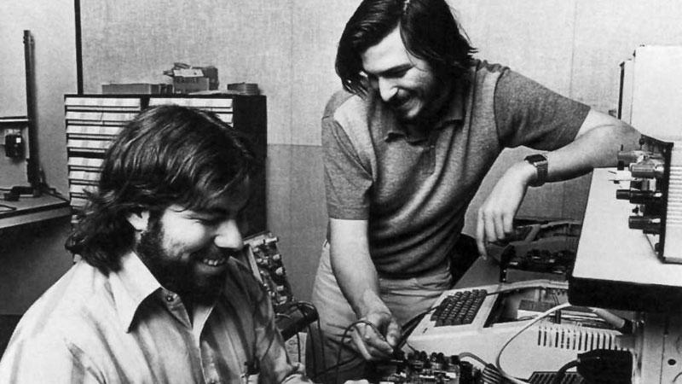

In this feature we tell the story of Apple. We start with the early days, the tale of how Apple was founded, moving on through the Apple I, to the Apple II, the launch of the Macintosh and the revolution in the DTP industry... To the tech-industry behemoth that we know and love today.

So sit back as we take a stroll down memory lane. Why not brush up on what really happened before you go and watch the [Steve Jobs movie](https://www.macworld.co.uk/news/apple/steve-jobs-movie-review-reaction-ditched-sorkin-boyle-fassbender-rogan-uk-release-3584183/), with its interesting interpretations of several important events in the company's history?

On 1 April 1976 Apple was founded, making the company 41 years old as of the 1 April 2017 - here's a historical breakdown of the company.

**The history of Apple**

Our Apple history feature includes information about The foundation of Apple and the years that followed, we look at How Jobs met Woz and Why Apple was named Apple. The Apple I and The debut of the Apple II. Apple's visit to Xerox, and the one-button mouse. The story of The Lisa versus the Macintosh. Apple's '1984' advert, directed by Ridley Scott. The Macintosh and the DTP revolution.

We go on to examine what happened between Jobs and Sculley, leading to Jobs departure from Apple, and what happened during The wilderness years: when Steve Jobs wasn't at Apple, including Apple's decline and IBM and Microsoft's rise and how Apple teamed up with IBM and Motorola and eventually Microsoft. And finally, The return of Jobs to Apple.

**The foundation of Apple**

The history of everyone's favorite start-up is a tech fairytale of one garage, three friends and very humble beginnings. But we're getting ahead of ourselves…

SPONSORED CONTENT

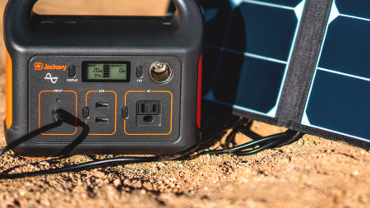

[**Jackery's Portable Power Solutions Keep Your MacBook Going All Day**](https://www.macworld.co.uk/news/apple/jackery-deal-3780246/)

by [Jackery](https://www.macworld.co.uk/news/apple/jackery-deal-3780246/)

Never let your iPhone run out of power again. Jackery's range of portable solutions provide power no matter how far and for how long you go off...

The two Steves - [Jobs](https://www.macworld.co.uk/steve-jobs/) and [Wozniak](https://www.macworld.co.uk/feature/apple/steve-wozniak-trivia-10-surprising-facts-about-woz-3494707/) - may have been Apple's most visible founders, but were it not for their friend Ronald Wayne there might be no [iPhone](https://www.macworld.co.uk/review/iphone/), [iPad](https://www.macworld.co.uk/review/ipad/) or [iMac](https://www.macworld.co.uk/review/imac/) today. Jobs convinced him to take 10% of the company stock and act as an arbiter should he and Woz come to blows, but Wayne backed out 12 days later, selling for just $500 a holding that would have been worth $72bn 40 years later.



*Ron Wayne*

**How Jobs met Woz**

Jobs and Woz (that's Steve Wozniak) were introduced in 1971 by a mutual friend, Bill Fernandez, who went on to become one of Apple's earliest employees. The two Steves got along thanks to their shared love of technology and pranks.

Jobs and Wozniak joined forces, initially coming up with pranks such as rigging up a painting of a hand showing the middle-finger to be displayed during a graduation ceremony at Jobs' school, and a call to the Vatican that nearly got them access to the Pope.

The two friends were also using their technology know-how to build 'blue boxes' that made it possible to make long distance phone calls for free.

Trending Articles



**How to transfer data from an old iPhone to a new one**

Got a new iPhone? Great! All you need to do now is transfer all your data…

[Powered By](https://i.jsrdn.com/i/1.gif?r=whbs&k=&fwd=http%3A%2F%2Fdistroscale.com)



Jobs and Wozniak worked together on the Atari arcade game Breakout while Jobs was working at Atari and Wozniak was working at HP - Jobs had roped Woz into helping him reduce the number of logic chips required. Jobs managed to get a good bonus for the work on Breakout, of which he gave a small amount to Woz.

**The first Apple computer**

The two Steves attended the Homebrew Computer Club together; a computer hobbyist group that gathered in California's Menlo Park from 1975. Woz had seen his first MITS Altair there - which today looks like little more than a box of lights and circuit boards - and was inspired by MITS' build-it-yourself approach (the Altair came as a kit) to make something simpler for the rest of us. This philosophy continues to shine through in Apple’s products today.

So Woz produced the first computer with a typewriter-like keyboard and the ability to connect to a regular TV as a screen. Later christened the Apple I, it was the archetype of every modern computer, but Wozniak wasn't trying to change the world with what he'd produced - he just wanted to show off how much he'd managed to do with so few resources.

Speaking to NPR (National Public Radio) in 2006, Woz explained that "When I built this Apple I… the first computer to say a computer should look like a typewriter - it should have a keyboard - and the output device is a TV set, it wasn't really to show the world [that] here is the direction [it] should go [in]. It was to really show the people around me, to boast, to be clever, to get acknowledgement for having designed a very inexpensive computer."

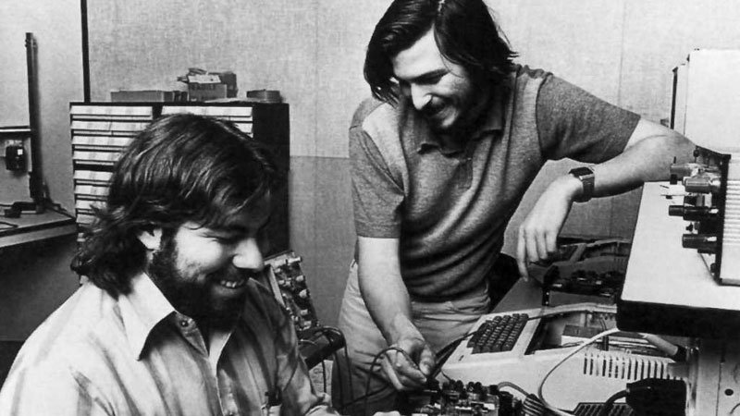

*Jobs and Woz*

**Sponsored Links**

[Read This Before You Renew Amazon Prime AgainWikibuy](https://wikibuy.com/blog/is-amazon-actually-giving-you-the-best-price-779e00e8958e?utm_source=Newton&utm_campaign=001869cd481f8c188e3573bd25a38a76f4&utm_term=00fca24589397b10b45d179c02a971fadd&obOrigUrl=true" \t "_blank)

[Best Travel Credit Cards of 2020NerdWallet](https://www.nerdwallet.com/ur/?utm_content=766653&nw_campaign_id=151208965164223300&utm_medium=ntv&utm_source=ob&utm_campaign=cc_mktg_paid_070119_trav_lalmclick_perf_d_ob&utm_term=$publisher_id$&mktg_place=$section_id$&outbrainClickId=$ob_click_id$&obOrigUrl=true" \t "_blank)

[Get Rid Of Debris, Leaves Or Pine Needles In Your Gutters For Life!leaffilterguards.com](http://www.mnbasd77.com/aff_c?offer_id=2024&aff_id=2600&url_id=6346&source=Brian&aff_sub=CampaignName&aff_sub2=$publisher_name$_$section_name$&aff_sub3=0063d3dd6ce36fc78a5dc03964eeb3c542_Get+Rid+Of+Debris%2C+Leaves+Or+Pine+Needles+In+Your+Gutters+For+Life%21&aff_sub4=00c2c21258ac752c3568a938f248224d99&source=Brian&aff_sub=VK_LF_Desk-Newaccount-BestZips3&aff_sub2=$publisher_name$_$section_name$&aff_sub3=0063d3dd6ce36fc78a5dc03964eeb3c542_Get+Rid+Of+Debris%2C+Leaves+Or+Pine+Needles+In+Your+Gutters+For+Life%21&aff_sub4=00c2c21258ac752c3568a938f248224d99&obOrigUrl=true" \t "_blank)

[Recommended by](https://www.outbrain.com/what-is/default/en)

It almost didn't happen, though. The Woz we know now has a larger-than-life personality - he's funded rock concerts and shimmied on Dancing with the Stars - but, as he told the Sydney Morning Herald, "I was shy and felt that I knew little about the newest developments in computers." He came close to ducking out altogether, and giving the Club a miss.

Let's be thankful he didn't. Jobs saw Woz's computer, recognized its brilliance, and sold his VW microbus to help fund its production. Wozniak sold his HP calculator (which cost a bit more than calculators do today!), and together they founded Apple Computer Inc on 1 April 1976, alongside Ronald Wayne.

**Why Apple was named Apple**

The name Apple was to cause Apple problems in later years as it was uncomfortably similar to that of the Beatles' publisher, Apple Corps, but its genesis was innocent enough.

[Speaking to Byte magazine in December 1984](https://go.redirectingat.com/?id=803X112722&xcust=41-3606104-11-0000000&sref=https%3A%2F%2Fwww.macworld.co.uk%2Ffeature%2Fapple%2Fhistory-of-apple-steve-jobs-mac-3606104%2F&xs=1&url=http%3A%2F%2Farchive.org%2Fstream%2Fbyte-magazine-1984-12%2F1984_12_BYTE_09-13_Communications%23page%2Fn463%2Fmode%2F2up), Woz credited Jobs with the idea. "He was working from time to time in the orchards up in Oregon. I thought that it might be because there were apples in the orchard or maybe just its fruitarian nature. Maybe the word just happened to occur to him. In any case, we both tried to come up with better names but neither one of us could think of anything better after Apple was mentioned."

According to the biography of Steve Jobs, the name was conceived by Jobs after he returned from apple farm. He apparently thought the name sounded “fun, spirited and not intimidating.”

The name also likely benefitted by beginning with an A, which meant it would be nearer the front of any listings.

The Apple Logo

There are other theories about the meaning behind the name Apple. The idea that it was named thus because Newton was inspired when an Apple fell out of a tree hitting him on the head, is backed up by the fact that the original Apple logo was a rather complicated illustration of Newton sitting under a tree.

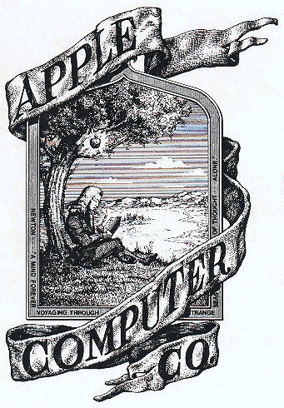

Later the company settled on the bite out of an Apple design for Apple's logo - a far simpler logo design. These logos are probably the reason for other theories about the meaning behind the name Apple, with some suggesting that the Apple logo with a chunk taken out of it is a nod at computer scientist and Enigma code-breaker, Alan Turing, who committed suicide by eating a cyanide infused apple.

However, according to Rob Janoff, the designer who created the logo, the Turing connection is simply "a wonderful urban legend."

Equally the bite taken out of the Apple could represent the story of Adam and Eve from the Old Testament. The idea being that the Apple represents knowledge.

**Selling the Apple I**

Woz built each computer by hand, and although he'd wanted to sell them for little more than the cost of their parts - at a price at that would recoup their outlay as long as they shipped 50 units - Jobs had bigger ideas.

Jobs inked a deal with the Byte Shop in Mountain View to supply it with 50 computers at $500 each. This meant that once the store had taken its cut, the Apple I sold for $666.66 - the legend is that Wozniak liked repeating numbers and was unaware of the 'number of the beast' connection.

Byte Shop was going out on a limb: the Apple I didn't exist in any great numbers, and the nascent Apple Computer Inc didn't have the resources to fulfil the order. Neither could it get them. Atari, where Jobs worked, wanted cash for any components it sold him, a bank turned him down for a loan, and although he had an offer of $5,000 from a friend's father, it wasn't enough.

In the end, it was Byte Shop's purchase order that sealed the deal. Jobs took it to Cramer Electronics and, as [Walter Isaacson](https://www.macworld.co.uk/news/apple/walter-isaacson-discusses-apple-steve-jobs-3349305/) explains in [Steve Jobs: The Exclusive Biography](https://buy.geni.us/Proxy.ashx?TSID=13305&GR_URL=http%3A%2F%2Fwww.amazon.co.uk%2Fdp%2F1408703742%2F%3Fascsubtag%3D41-3606104-11-0000000), he convinced Cramer's manager to call Paul Terrell, owner of Byte Shop, to verify the order.

"Terrell was at a conference when he heard over a loudspeaker that he had an emergency call (Jobs had been persistent). The Cramer manager told him that two scruffy kids had just walked in waving an order from the Byte Shop. Was it real? Terrell confirmed that it was, and the store agreed to front Jobs the parts on thirty-day credit."

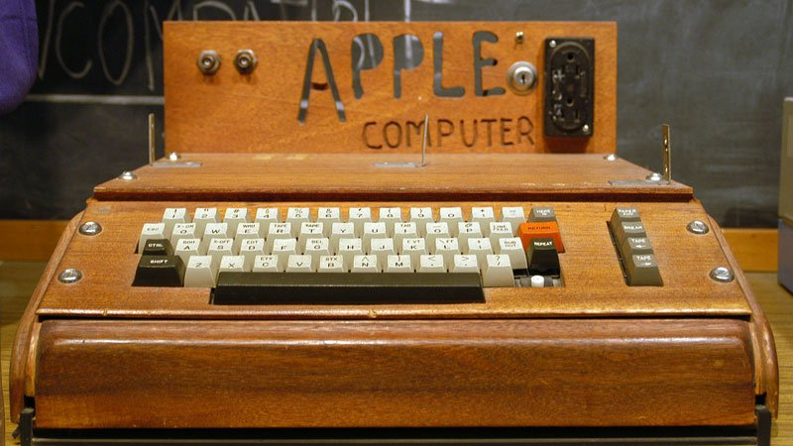

*An original Apple I (in a case)*

Jobs was banking on producing enough working computers within that time to settle the bill out of the proceeds from selling completed units to Byte Shop. The risk involved was too great for Ronald Wayne, and it's ultimately this that saw him duck out.

"Jobs and Woz didn't have two nickels to rub together," [Wayne told NextShark in 2013](https://go.redirectingat.com/?id=803X112722&xcust=41-3606104-11-0000000&sref=https%3A%2F%2Fwww.macworld.co.uk%2Ffeature%2Fapple%2Fhistory-of-apple-steve-jobs-mac-3606104%2F&xs=1&url=http%3A%2F%2Fnextshark.com%2Fronald-wayne-interview%2F). "If this thing blew up, how was that… going to be repaid? Did they have the money? No. Was I reachable? Yes."

Family and friends were roped in to sit at a kitchen table and help solder the parts, and once they'd been tested Jobs drove them over to Byte Shop. When he unpacked them, Terrell, who had ordered finished computers, was surprised by what he found.

As Michael Moritz explains in [Return to the Little Kingdom](https://buy.geni.us/Proxy.ashx?TSID=13305&GR_URL=http%3A%2F%2Fwww.amazon.co.uk%2Fdp%2F0715638882%2F%3Fascsubtag%3D41-3606104-11-0000000), "Some energetic intervention was required before the boards could be made to do anything. Terrell couldn't even test the board without buying two transformers… Since the Apple I didn't have a keyboard or a television, no data could be funneled in or out of the computer. Once a keyboard had been hooked to the machine it still couldn't be programmed without somebody laboriously typing in the code for BASIC since Wozniak and Jobs hadn't provided the language on a cassette tape or in a ROM chip… finally the computer was naked. It had no case."

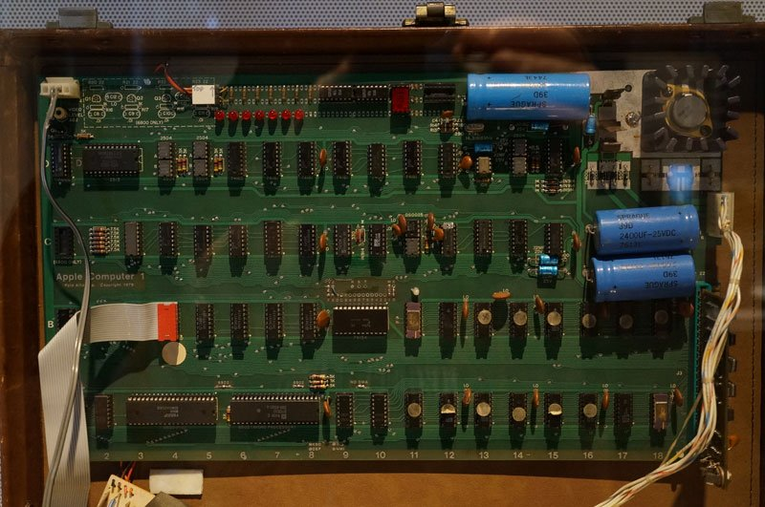

*An original Apple I board, from the Sydney Powerhouse Museum collection*

Raspberry PI and the BBC's Micro Bit aside, we probably wouldn’t accept such a computer today, and even Terrell was reluctant at first but, as Isaacson explains, "Jobs stared him down, and he agreed to take delivery and pay." The gamble had paid off, and the Apple I stayed in production from April 1976 until September 1977, with a total run of around 200 units.

Their scarcity has made them collectors' items, and Bonhams auctioned a working Apple I in October 2014 for an eye-watering $905,000. If your pockets aren't that deep, Briel Computers' [Replica 1 Plus](https://go.redirectingat.com/?id=803X112722&xcust=41-3606104-11-0000000&sref=https%3A%2F%2Fwww.macworld.co.uk%2Ffeature%2Fapple%2Fhistory-of-apple-steve-jobs-mac-3606104%2F&xs=1&url=http%3A%2F%2Fwww.brielcomputers.com%2Fwordpress%2F%3Fcat%3D17) is a hardware clone of the Apple I, and ships at a far more affordable $199, fully built.

When you consider that only 200 were built, the Apple I was a triumph. It powered its burgeoning parent company to almost unheard-of rates of growth - so much so that the decision to build a successor can't have caused too many sleepless nights in the Jobs and Wozniak households.

**The Apple II**

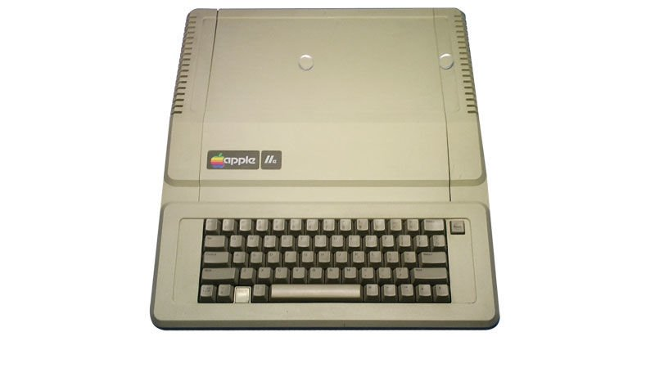

*Apple II*

The success of the first Apple computer meant that Apple was able to go on to design its predecessor.

The Apple II debuted at the West Coast Computer Faire of April 1977, going head to head with big-name rivals like the Commodore PET. It was a truly groundbreaking machine, just like the Apple computer before it, with color graphics and tape-based storage (later upgraded to 5.25in floppies). Memory ran to 64K in the top-end models and the image it sent to the NTSC display stretched to a truly impressive 280 x 192, which was then considered high resolution. Naturally there was a payoff, and pushing it to such limits meant you had to content yourself with just six colors, but dropping to a more reasonable 40 rows by 48 columns would let you enjoy as many as 16 tones at a time.

Yes, the Apple II (or **apple ][** as it was styled) was a true innovation, and one that Jobs' biographer, [Walter Isaacson](https://www.macworld.co.uk/news/apple/walter-isaacson-discusses-apple-steve-jobs-3349305/), credits with launching the personal computer industry.

The trouble is, the specs alone weren't really enough to justify the $1,300 cost of the Apple II. Business users needed a reason to dip into their IT budgets and it wasn't until some months later that the perfect excuse presented itself: the world’s first 'killer app'.

The first app on an Apple computer: Visicalc



*Dan Bricklin*

Dan Bricklin was a student at Harvard Business School when he [visualized](https://go.redirectingat.com/?id=803X112722&xcust=41-3606104-11-0000000&sref=https%3A%2F%2Fwww.macworld.co.uk%2Ffeature%2Fapple%2Fhistory-of-apple-steve-jobs-mac-3606104%2F&xs=1&url=http%3A%2F%2Fwww.bricklin.com%2Fhistory%2Fsaiidea.htm) "a heads-up display, like in a fighter plane, where I could see the virtual image [of a table of numbers] hanging in the air in front of me. I could just move my mouse/keyboard calculator around on the table, punch in a few numbers, circle them to get a sum, do some calculations…"

Of course, we'd recognize that as a spreadsheet today, but back in the late 1970s, such things existed only on paper. Converting them for digital use would be no small feat, but Bricklin was unperturbed. He borrowed an Apple II from his eventual publisher and set to work, knocking out an alpha edition over the course of a weekend.

Many of the concepts he used are still familiar today - in particular, letters above each column and numbers by the rows to use as references when building formulae. (Wondering how it compares to Numbers today? Here's our [Numbers review](https://www.macworld.co.uk/review/office-software/numbers-30-2013-mac-review-update-apples-excel-alternative-3476157/).)

The technological limitations inherent in the hardware meant that it didn't quite work as Bricklin had first imagined. The Apple II didn't have an incorporated display and although the mouse had been invented it wasn't bundled with the machine. So, the display became the regular screen, and the mouse was swapped out for the Apple II's game paddle, which Bricklin described as being "a dial you could turn to move game objects back and forth... you could move the cursor left or right, and then push the 'fire' button, and then turning the paddle would move the cursor up and down."

It was far from perfect and working this way was sluggish, so Bricklin reverted to using the left and right arrow keys, with the space bar in place of the fire button for switching between horizontal and vertical movement.

VisiCalc was unveiled in 1979 and described as "a magic sheet of paper that can perform calculations and recalculations". We owe it a debt of gratitude for the part it played in driving sales of the Apple II and anchoring Apple within the industry.

Writing in Morgan Stanley's *Electronics Letter*, shortly before its launch, analyst Benjamin M Rosen expounded his belief that VisiCalc was "so powerful, convenient, universal, simple to use and reasonably priced that it could well become one of the largest-selling personal computer programs ever... [it] could someday become the software tail that wags (and sells) the personal computer dog."

How right he was, as Tim Barry revealed in a [later InfoWorld piece](https://go.redirectingat.com/?id=803X112722&xcust=41-3606104-11-0000000&sref=https%3A%2F%2Fwww.macworld.co.uk%2Ffeature%2Fapple%2Fhistory-of-apple-steve-jobs-mac-3606104%2F&xs=1&url=https%3A%2F%2Fbooks.google.co.uk%2Fbooks%3Fid%3DJT0EAAAAMBAJ%26lpg%3DPA3%26ots%3DUIUJBsfNdl%26pg%3DRA1-PA30%26redir_esc%3Dy%23v%3Donepage%26q%26f%3Dfalse) in which he described an experience that would have been familiar to many:

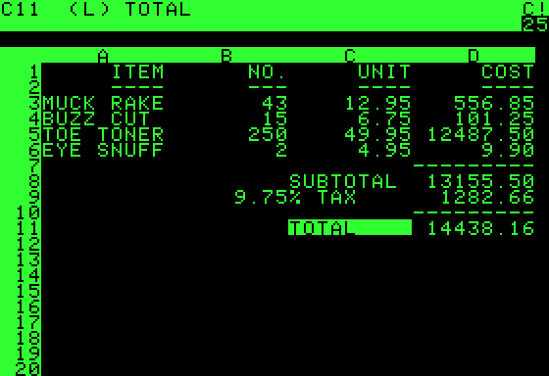

*VisiCalc*

"When I first used VisiCalc on an Apple II, I wanted to get a version that could take advantage of the larger system capabilities of my CP/M computer. Alas it was not to be... We ended up buying an Apple II just to run VisiCalc (a fairly common reason for many Apple sales, I'm told)."

Apple itself [credited the app](https://www.macworld.co.uk/opinion/mac/simon-jary-v-are-champions-3486179/) with being behind a fifth of all series IIs it sold.

Apple II success: color graphics

So a piece of software worth a little more than $100 was selling a piece of hardware worth ten times as much. That was uncharted territory, but even with the right software the Apple II wouldn't have been a success if it hadn't adhered to the company's already established high standards.

The February 1984 edition of *PC Mag*, looking back at the Apple II in the context of what it had taught IBM, put some of its success down to the fact that "its packaging did not make it look like a ham radio operator's hobby. A low heat-generating switching power supply allowed the computer to be placed in a lightweight plastic case. Its sophisticated packaging differentiated it from ... computers that had visible boards and wires connecting various components to the motherboard."

More radically, though, the [Apple II](https://go.redirectingat.com/?id=803X112722&xcust=41-3606104-11-0000000&sref=https%3A%2F%2Fwww.macworld.co.uk%2Ffeature%2Fapple%2Fhistory-of-apple-steve-jobs-mac-3606104%2F&xs=1&url=http%3A%2F%2Fbooks.google.co.uk%2Fbooks%3Fid%3DUCIvSU6Y2GAC%26lpg%3DPP1%26pg%3DPA120%26redir_esc%3Dy%23v%3Donepage%26q%26f%3Dfalse) "was the first of its type to provide usable color graphics... contained expansion slots for which other hardware manufacturers could design devices that could be installed into the computer to perform functions that Apple has never even considered."

In short, Apple had designed a computer that embodied what we came to expect of desktop machines through the 1980s, 1990s and the first few years of this century - before Apple turned things on its head again and moved increasingly towards sealed boxes without the option for internal expansion.

Almost six million series IIs were produced over 16 years, giving Apple its second big hit. Really, though, the company was still getting started, and its brightest days were still ahead.

For VisiCalc, the future wasn't so bright, largely because its developers weren't quick enough to address the exploding PC market. Rival Lotus stepped in and its 1-2-3 quickly became the business standard. It bought Software Arts, VisiCalc's developer, in 1985 and remained top dog until Microsoft did to it what Lotus had done to VisiCalc - it usurped it with a rival that established a new digital order.

That rival was Excel which, like VisiCalc, appeared on an Apple machine long before it was ported to the PC.

[Jump to top of article](https://www.macworld.co.uk/feature/apple/history-of-apple-steve-jobs-mac-3606104/#history)

**Apple, Xerox and the one-button mouse**

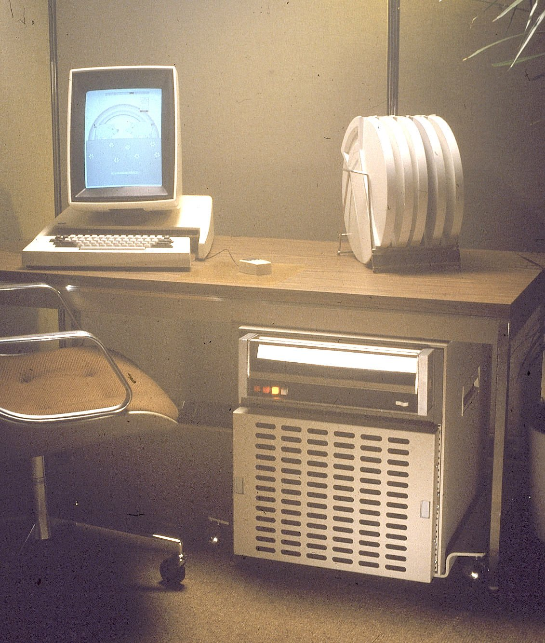

Apple has never been slow to innovate - except, perhaps, where product names are concerned. We're approaching the eighties in our trip through the company's history and we're at the point where it's followed up the Apple I and II with the III. Predictable, eh?

The two Steves founded the company with a trend-bucking debut and had the gumption to target the industry’s biggest names with its two follow ups. That must have left industry watchers wondering where it might go next.

The answer, it turned out, was Palo Alto.

Xerox had established a research Centre there - Xerox PARC, now simply called 'parc' - where it was free to explore new technologies a long way from the corporate base on the opposite side of the country. Its work helped drive forward the tech that we still use every day, such as optical media, Ethernet and laser printers (we aren't just talking about photocopiers!) Of most interest to Mac users, though, is its revolutionary work on interface design.

The Apple I,  II and III computers were text-based machines, much like the earliest IBM PCs. But Jobs, who was working on the Lisa at the time, wanted something more intuitive. He convinced Xerox to grant three days’ access to PARC for him and a number of Apple employees. In exchange Xerox won the right to buy 100,000 Apple shares at $10 each.

To say this was a bargain would be a massive understatement. [Apple has split its](https://www.macworld.co.uk/how-to/apple/how-invest-apple-guide-buying-aapl-shares-3449839/) stock four times since then - in 1987, 2000, 2005 and 2014. Companies do this when the price of a single share starts to get too high, in an effort to stimulate further trading. So, assuming Xerox held on to those shares, it would have had 200,000 by 1987, 400,000 by 2000 and 800,000 by 2005. The split in 2014 was rated at seven to one, so Xerox's holding would leap from 800,000 to 5.6m. Selling them at today's prices would rake in $708m (£450m). Not bad for a three-day tour.

Jobs was bowled over by the Xerox Alto, a machine used widely throughout the park, with a portrait display and graphical interface, which was way ahead of its time. It had been knocking around for a while by then, but Xerox, which built 2000 units, hadn’t been selling it to the public. It wasn't small - about the size of an under-counter fridge - but it was still considered a 'personal' machine, which was driven home by the user-centric manner in which it was used. It was the first computer to major on mouse use, with a three-button gadget used to point at and click on objects on the screen.

Jobs decreed that every computer Apple produced from that point on should adopt a similar way of working. Speaking to [Walter Isaacson](https://www.macworld.co.uk/news/apple/walter-isaacson-discusses-apple-steve-jobs-3349305/) some years later, he described the revelation as "like a veil being lifted from my eyes. I could see what the future of computing was destined to be."

**The Lisa and the Macintosh**

It kicked off a race inside Apple between the teams developing the Lisa and the Macintosh.

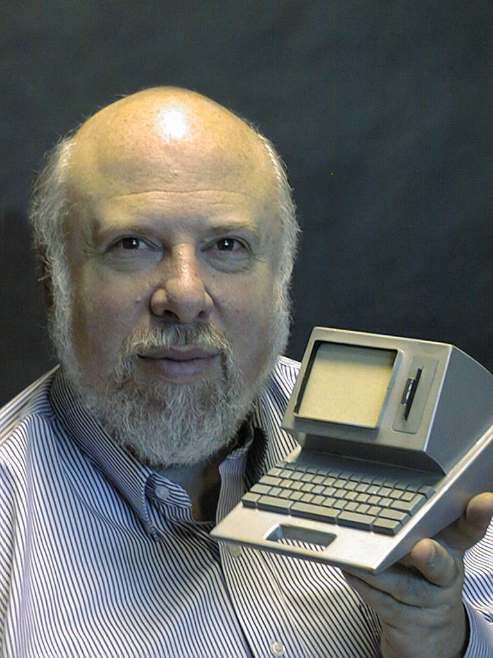

*Jeff Raskin*

The official line at the time was that Lisa stood for Local Integrated System Architecture, and the fact it was Jobs' daughter's name was purely coincidental. It was a high-end business machine slated to sell at close to $10,000. Convert that to today’s money and it would buy you a mid-range family car. The project was managed by John Couch, formerly of IBM.

Jeff Raskin, meanwhile, was heading up development of the [Macintosh](https://www.macworld.co.uk/mac-at-30/), which had smaller businesses and home users firmly in its sights, and each team wanted to be the first to ship an Apple computer with a graphical interface.

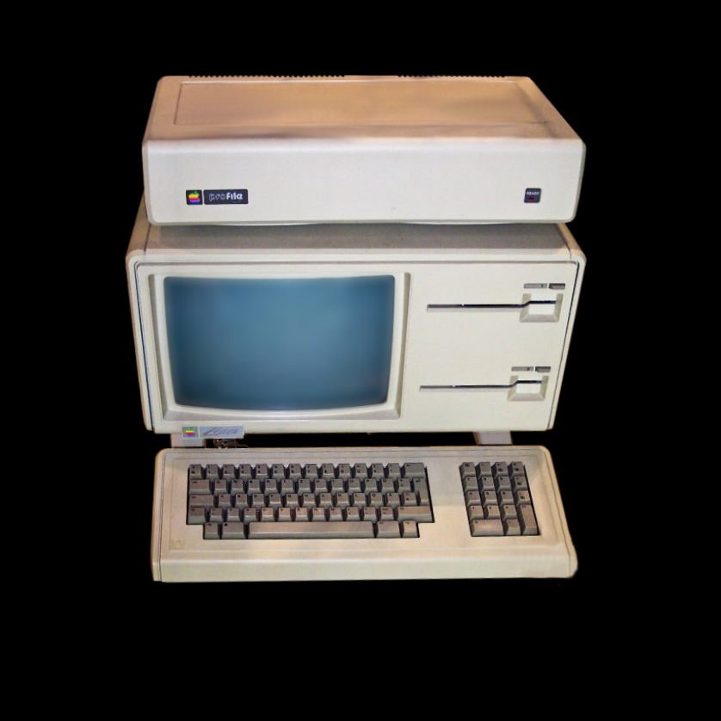

*The Lisa*

Whichever team got their first, Apple - as a company - wanted them to do it at a price that wasn't prohibitively expensive, and that meant finding some cheaper solutions to the ones arrived at by Xerox. The Alto’s mouse, for example, had three buttons and cost $300. Jobs wanted something simpler, and capped the price at $15. The result was a one-button mouse (which maybe hasn't stood the test of time as well as Jobs might have expected, with most of us regularly requiring that ctrl-click or right-click).

Jobs was so excited by the potential of the mouse and graphical interface that he got himself more and more involved in the Lisa's development, to the extent that he started to bypass the management structure already in place. The caused upsets, and in 1982 matters came to a head.

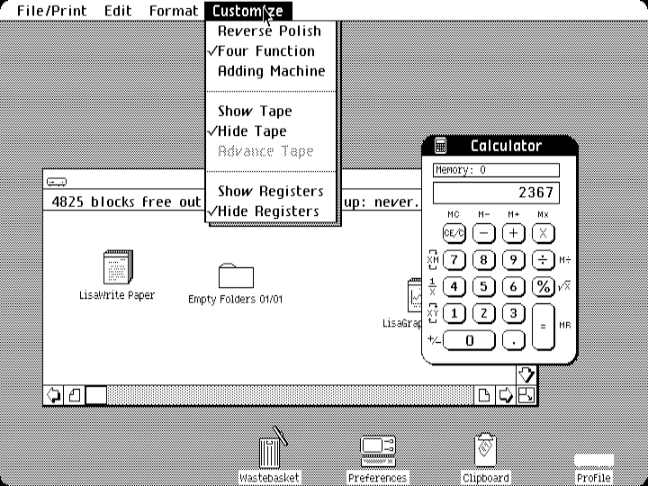

*The Apple Lisa had an advanced gui*

Michael Scott was Apple's president and CEO at the time, having been brought to the post by Mark Markkula (Apple employee number three, and investor to the tune of $250,000). The two men worked out a new corporate structure, which sidelined Jobs with immediate effect, and handed control of the Lisa project back to John Couch. Jobs, also stripped of responsibility for research and development within the company, was little more than a figurehead. That left him on the lookout for a new project.

Perhaps inevitably, he turned to the Macintosh.

Named in honor of Raskin's favorite edible apple (the [McIntosh](https://go.redirectingat.com/?id=803X112722&xcust=41-3606104-11-0000000&sref=https%3A%2F%2Fwww.macworld.co.uk%2Ffeature%2Fapple%2Fhistory-of-apple-steve-jobs-mac-3606104%2F&xs=1&url=http%3A%2F%2Fwww.orangepippin.com%2Fapples%2Fmcintosh)), the Macintosh had been in the works since 1979, so when Jobs joined the team it was already well advanced. That didn’t stop him making extensive changes though, including the commission of a new external design and integration the graphical operating system. Raskin left the Macintosh team when he and Jobs fell out, and Jobs assumed control for the remainder of its development.

However, this enforced switching of sides meant that Jobs - technically - ended up on the losing team. The Lisa launched in 1983, with its graphical user interface in place; the Macintosh debuted the following year. The race had been won by the Lisa.

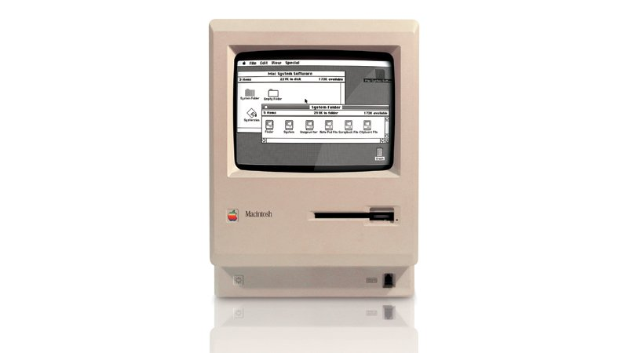

It was a pyrrhic victory, though. The Macintosh, which we'll be covering in more detail below, was a success, and Apple's current computer line-up - iOS devices aside - descends directly from that first consumer machine.

You can't say the same of the Lisa. It cost four times the price of the Macintosh, and although it had a higher resolution display and could address more memory, it wasn't nearly as successful. Apple released seven applications for it, covering all of the usual business bases, but third party support was poor.

Nonetheless, Apple didn’t give up. The original Lisa was followed by the Lisa 2, which cost around half the price of its predecessor and used the same 3.5in disks as the Macintosh. Then, in 1985, it rebranded the hard drive-equipped Lisa 2 as the Macintosh XL and stimulated sales with a price cut.

At this point, though, the numbers didn't add up, and the Lisa had to go. The Macintosh went on to define the company.

By 1984, Apple had proved twice over that it was a force to be reckoned with. It had taken on IBM, the biggest name in business computing, and acquitted itself admirably. The Apple I and II were resounding successes, but while the Apple III and Lisa had been remarkable machines, they hadn’t captured the public imagination to the same degree as their predecessors. Apple needed another hit, both to guarantee its future and to target the lower end of the market, which to date it had largely ignored.

That hit, we all now know, was the Macintosh: the machine that largely guaranteed the company's future.

If you'd like a visual guide to Apple history take a look at our[Apple timeline in pictures and video](https://www.macworld.co.uk/feature/mac/30-years-mac-mac-timeline-pictures-24596/)

All change: Jef Raskin versus Steve Jobs

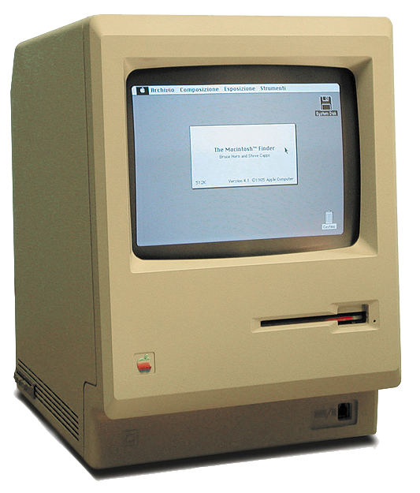

*The Macintosh*

We'll always remember Steve Jobs as the man who launched the Macintosh, but he only arrived on the project in 1981 - two years after Jef Raskin had started work on the low-cost computer for home and business use. Jobs quickly stamped his mark on it, and Raskin left in 1982 - before the product shipped. We must give Raskin credit for original idea and its name (his favorite kind of apple was the McIntosh, but this was tweaked to avoid infringing copyright), but otherwise the machine that eventually launched was a fair way away from the one he’d originally envisaged.

Raskin's early prototypes had text-based displays and used function keys in place of the mouse for executing common tasks. Raskin later endorsed the mouse, but with more than the single button that shipped with the Macintosh. It was Jobs and Bud Tribble, the latter of whom is still at Apple (he is Vice President of Software Technology), that really pushed the team to implement the graphical user interface (GUI) for which it became famous.

They saw the potential of the GUI’s desktop metaphor after seeing one in use at Xerox PARC, and they'd already laid much of the groundwork for Apple's own take on the system as part of the Lisa project. Tribble tasked the Macintosh team with doing the same for their own machine which, in hindsight, may have been the most important directive ever issued by anyone inside Apple.

If the Macintosh team had continued down the text-and-keyboard path, it's unlikely their product would have sold as well as it did - and Apple, as we know it, might not exist today at all.

Find out about the [original Mac team members - here are some of their stories](https://www.macworld.co.uk/feature/mac/mac-30th-celebration-original-mac-team-members-share-their-stories-3499130/).

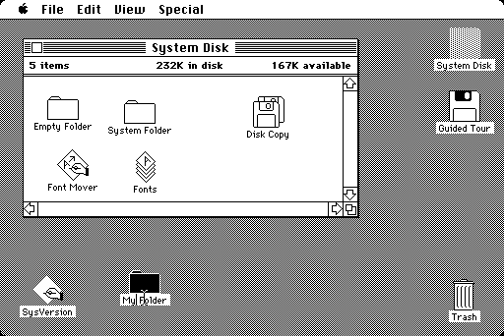

The Macintosh project: Simpler and smarter

Through several iterations, the prototype Macintosh became both more able and less complex to build. It had fewer chips, and the Apple engineers were able to push them further and faster. By the time it was ready to launch, the Macintosh incorporated the kind of graphics hardware that would have cost tens of thousands of pounds to buy in any rival machine, yet Apple was aiming to sell it at a price that would put it in reach of the better-heeled home user.

The final spec was radical for its day, with a 6MHz Motorola 68000 processor ramped up to 7.8MHz, 128KB of Ram, and a 9in black and white screen with a fixed 512 x 342 pixels. To put that into perspective, it’s not even enough to display an app icon from a retina-class iOS device at its native resolution, but it could still accommodate System Software 1.0 – Apple's fully graphical operating system.

The Macintosh project: good looks

But it wasn't just what went on inside the box that made it such an attractive device. The Macintosh looked just good on the outside. Sure, it was shrouded in beige plastic – but the all in one body incorporated the floppy drive and a handy carrying handle, so you could easily take it with you, wherever you needed to work. It looked friendly, too, and that made it more approachable.

There were still some limitations, though. The original Macintosh didn't have a hard drive, so you had to boot from a floppy and could only temporarily eject the system disk when you needed to access applications and data. Apple partially fixed this shortcoming by offering an external add-on drive, which allowed users to keep the System disk in situ and delegate responsibility for apps and data to a second disk. It was an expensive add-on, though, and the external Hard Disk 20, which cost $1495 and gave just 20MB of storage, was still a year away from going on sale.

Despite its limitations, though, many of the features established on that first Macintosh are still in use today. We've dropped the 'System' moniker in favor of 'OS' (which stands for Operating System), but we still use the Finder name, which debuted there, and both Command and Option appeared as modifier buttons on its keyboard (the latter has since been usurped by alt, at least in the UK, but the name lives on for many users).

(You'd be surprised by how many people are confused by the fact that Apple still refers to the Option key on the Mac keyboard even though on UK keyboards that key is known as Alt, find out more here**:** [What is Option on a Mac?)](https://www.macworld.co.uk/how-to/mac/what-where-option-key-mac-3462401/)

The Macintosh project: pixels

The hardware was only half of the story. Coder Bill Atkinson had implemented a radical system by which the Macintosh System software allowed for overlapping windows in a more efficient manner than the computers at PARC had done, and [Susan Kare](https://www.macworld.co.uk/opinion/apple/simon-jary-apples-serial-special-ks-3486150/) spent months developing a visual language in the form of on-screen icons that have since become classics.



*Susan Kare and the Command logo she designed*

It’s Kare that we have to thank for the on-screen wrist watch (to indicate a background process hogging resources) and the smiling Mac – among others – as well as the seemingly illogical square and circles combination she chose for the command key. (This is a common symbol in Sweden, where it’s used to denote a National Heritage site - not a campsite as has been reported.) Her paint bucket and lasso graphics are used widely in other applications, and the fonts she designed for use on the original Macintosh, which included Chicago, Geneva and Monaco, are still in use today – albeit in finer forms.

The Macintosh went on sale in January 1984, priced at $2,495. It wasn't cheap, but it was good value for what you got, and that was reflected in its sales. By the beginning of May that same year, Apple had hit the landmark figure of 70,000 shipped units, which was likely helped in no small part by a remarkable piece of advertising directed by Ridley Scott.

Find out how the [iPhone 5s compares to the Original 128k Macintosh](https://www.macworld.co.uk/feature/iphone/iphone-vs-original-mac-head-to-head-3242144/)

[Jump to top of article](https://www.macworld.co.uk/feature/apple/history-of-apple-steve-jobs-mac-3606104/#history)

**Apple's '1984' advert**

Nobody would ever deny that the original Macintosh was a work of genius. It was small, relatively inexpensive (for its day) and friendly. It brought the GUI – graphical user interface – to a mass audience and gave us all the tools we could ever need for producing graphics-rich work that would have costs many times as much on any other platform.

Yet, right from the start, it was in danger of disappointing us.

You see, Apple had built it up to be something quite astounding. It was going to change the computing world, we were told, and as launch day approached, the hype continued to grow. It was a gamble – a big one – that any other company would likely have shied away from.

But then no other company employed Steve Jobs.

Jobs understood what made the Macintosh special, and he knew that, aside from the keynote address at which he would reveal it, the diminutive machine needed a far from diminutive bit of publicity.

He put in a call to Chiat\Day, Apple’s retained ad agency, and tasked them with filling sixty seconds during the third quarter break of Super Bowl XVIII.

Super Bowl ads are always special, but this was in a league of its own. Directed by Blade Runner’s Ridley Scott and filmed in Shepperton Studios in the UK, its production budget stood somewhere between $350,000 and $900,000, depending on who is telling the story.

The premise was simple enough, but the message was a gamble, pitting Apple directly against its biggest competitor, IBM.

International Business Machines dominated the workplace of the early 1980s, and the saying that ‘nobody ever got fired for buying IBM’ was a powerful moniker working in its favor. People trusted the brand, staking their careers on the simple choice of IBM or one of the others. As a result, the others often missed out, and if Apple wasn’t going to languish among them, it had to change that perception.

So the ad portrayed Apple as humanity’s only hope for the future. It dressed Anya Major, an athlete who later appeared in Elton John’s Nikita video, in a white singlet and red shorts, with a picture of the Mac on her vest. She was bright, fresh and youthful, and a stark contrast to the cold, blue, shaven-headed drones all about her. They plodded while she ran. They were brainwashed by Big Brother, who lectured them through an enormous screen, but she hurled a hammer through the screen to free them from their penury.

Even without the tagline, the inference would have been clear, but Jobs, Apple CEO John Sculley and Chiat\Day turned the knife the with the memorable slogan, ‘On January 24th, Apple Computer will introduce Macintosh. And you'll see why 1984 won't be like Nineteen Eighty-Four.’

It was a gutsy move, never explicitly naming IBM, and never showing the product it was promoting, but today it's considered a masterpiece, and has topped *Advertising Age*'s list of the 50 greatest commercials ever made.

Jobs and Sculley loved it, but when Jobs played it to the board, it got a frosty reception. The board disliked it and Sculley changed his mind, suggesting that they find another agency, but not before asking Chiat\Day to sell off the two ad slots they’d already booked it into.

One of these was a minor booking, slated to run on just ten local stations in Idaho, purely so the ad would qualify for the 1983 advertising awards. Chiat\Day offloaded this as instructed, but hung on to the Super Bowl break and claimed that it was unsellable.

As Jobs' biographer, Walter Isaacson, explains, "Sculley, perhaps to avoid a showdown with either the board or Jobs, decided to let Bill Campbell, the head of marketing, figure out what to do. Campbell, a former football coach, decided to throw the long bomb. 'I think we ought to go for it,' he told his team."

Thank goodness they did.

There are two ways to judge an ad. One is how well it markets your brand, and the other is how much money is makes you. The 1984 promotion was a success on both fronts. Ninety-six million people watched its debut during the Super Bowl, and countless others caught a replay as television stations right across the country re-ran it later that evening, and over the following days.

Fifty local stations included a story on it in their new bulletins, which massively diluted the $800,000 cost of the original slot. Apple couldn't have booked itself a cheaper ad break if it had tried.

The revenue speaks for itself. The ad, combined with Jobs’ now legendary keynote, secured the company's future, and kicked off a line of computers that's still with us today - albeit in a very different configuration.

It's perhaps no surprise that following the success of the 1984 advert, Apple booked another Super Bowl slot the following year for a strikingly similar production, this time filmed by Ridley Scott’s brother, Tony.

'Lemmings' once again depicted a stream of drones plodding across the screen. The colors were muted, the soundtrack was downbeat, and the drones were blindfolded, so it was only by keeping a hand on the drone ahead of them that they could tell where they were headed. Only when the penultimate drone dropped off the cliff over which they were marching did the last in line realize that a change of course was called for - and a switch to Macintosh Office.

It wasn't a great success. As stern design’s Apple Matters explains, the advert "left viewers with the feeling that they were inferior for not using the Mac. Turns out that insulting the very people you are trying to sell merchandise to is not the best idea."

Wired put it succinctly: "Apple fell flat on its face… People found it offensive, and when it was shown on the big screen at Stanford Stadium during the Super Bowl, there was dead silence - something very different from the cheers that greeted '1984' a year earlier."

[Jump to top of article](https://www.macworld.co.uk/feature/apple/history-of-apple-steve-jobs-mac-3606104/#history)

**The Macintosh and the DTP revolution**

The Macintosh got off to a good start, thanks to Jobs' spectacular unveiling, its innovative design, and the iconic '1984' advert, but it still needed a killer application, like VisiCalc had been on the Apple ][, if it was really going to thrive. It found it in the shape of PageMaker, backed up by the revolutionary Apple LaserWriter printer.

The $6,995 LaserWriter, introduced in March 1985 - just over a year after the Macintosh - was the first mass-market laser printer. It had a fixed 1.5MB internal memory for spooling pages and a Motorola 68000 processor under the hood - the same as the brain of both the Lisa and the Macintosh - running at 12MHz to put out eight 300dpi pages a minute.

It wasn't the first laser printer - just as the Macintosh wasn’t the first desktop machine and the iPod wasn't the first digital music player - but, in true Apple style, it was *different*, and that's what mattered. Functionally, it was very similar to the first HP Laserjet, which used the same Canon CX engine as the LaserWriter and had shipped a year earlier at half the price. However, while HP had chosen to use its own in-house control language, Apple opted for Adobe’s PostScript, which remains a cornerstone of desktop publishing to this day.

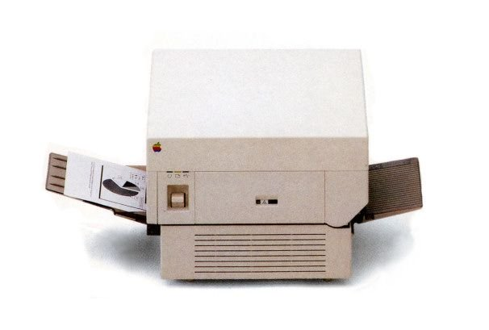

It was a neat fit for Adobe, which had been founded by John Warnock when he left Xerox with the intention of building a laser printer driven by the PostScript language. Jobs convinced him to work with Apple on building the LaserWriter, and sealed the deal shortly before the Macintosh launched.

As a key part of the Apple Office concept, introduced through 1985’s less popular *Lemmings* Super Bowl ad, the LaserWriter was network-ready out of the box, courtesy of AppleTalk, so system admins could string together a whole series of Macs in a chain and share the printer between them, thus reducing the average per-seat cost of the device. This made it immediately more competitive when stood beside its rivals and, as *InfoWorld* reported in its issue of February 11, 1985, "Apple claims a maximum of 31 users [can be attached] to each LaserWriter but its own departments at its Cupertino, California headquarters hook up 40 users per printer."

So, everything was in place on the hardware side. What was missing - so far - was the software.

Paul Brainerd, who is credited with inventing the term 'Desktop Publishing', heard of Apple's intention to build a laser printer and realized that the Mac's graphical interface and the printer's high quality output were missing the one crucial part that would help both of them fly: the intermediary application. Thus, he founded Aldus and began work on PageMaker.

The process took 16 months to complete, and when it shipped in July 1985, for $495, PageMaker proved to be the piece that completed the DTP jigsaw. The publishing industry was about to undergo a revolution, the like of which it wouldn't see again until we all started reading online.

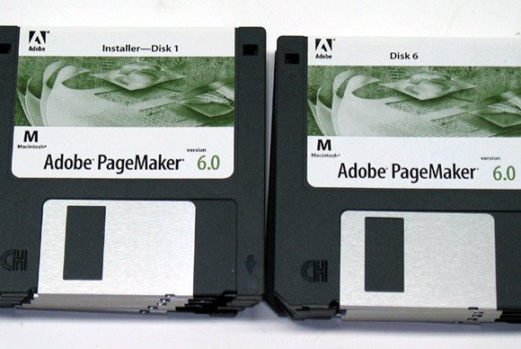

Although it was later available on Windows and VAX terminals, PageMaker started out on the Mac, and firmly established the platform as the first choice for digital creative work - which is perhaps why it's favored by so many designers today. It's hard to believe, in an age where we're used to 27in or larger displays, that the Macintosh’s 9in screen, with a resolution smaller than the pixel count of an iOS app icon, was ever considered a viable environment for laying out graphically-rich documents, but it was.

By March 1987, less than two years from launch, PageMaker’s annual sales had reached $18.4m - an increase of 100% over the previous year, according to [Funding Universe](https://go.redirectingat.com/?id=803X112722&xcust=41-3606104-11-0000000&sref=https%3A%2F%2Fwww.macworld.co.uk%2Ffeature%2Fapple%2Fhistory-of-apple-steve-jobs-mac-3606104%2F&xs=1&url=http%3A%2F%2Fwww.fundinguniverse.com%2Fcompany-histories%2Faldus-corporation-history%2F).

PageMaker versus QuarkXPress

But good things don't last forever, and eventually PageMaker lost a lot of its sales to QuarkXPress, which launched in 1987, undercut its high-end rivals and by the late 1990s had captured the professional market. In 1999 [Forbes](https://go.redirectingat.com/?id=803X112722&xcust=41-3606104-11-0000000&sref=https%3A%2F%2Fwww.macworld.co.uk%2Ffeature%2Fapple%2Fhistory-of-apple-steve-jobs-mac-3606104%2F&xs=1&url=http%3A%2F%2Fwww.forbes.com%2Fforbes%2F1999%2F0531%2F6311064a.html) reported that at one point 87% of the 18,000 magazines published in the US were being laid out using XPress (including Forbes itself).

Adobe and Aldus merged in 1994, retained the Adobe brand and transitioned products away from the Aldus moniker. It was a very logical pairing when you consider that PageMaker was conceived to take advantage of the graphics capabilities of an Apple laser printer, which in turn were served up by an Adobe-coded control language.

Quark was going from strength to strength at the time of the merger, and four years later – in summer 1998 – Quark Chief Executive Fred Ebrahimi, in Forbes’ words, ‘announced his intention to buy Adobe Systems of San Jose… a public company with three times Quark’s revenues’.

Quark versus InDesign

Of course, the acquisition didn’t go ahead, and what followed is now a familiar story to anyone in publishing. Adobe was already working on InDesign under the codename K2, using code that had come across with the Aldus merger. InDesign shipped in 1999 and after a few years of InDesign and PageMaker running side by side, the latter was retired.

PageMaker’s last major release was version 7, which shipped in 2001 and ran on both Windows and OS 9 or OS X, although only in Classic mode on the latter. It’s no doubt still in use on some computers and lives on in the shape of the archived pages on Adobe’s site [here](https://go.redirectingat.com/?id=803X112722&xcust=41-3606104-11-0000000&sref=https%3A%2F%2Fwww.macworld.co.uk%2Ffeature%2Fapple%2Fhistory-of-apple-steve-jobs-mac-3606104%2F&xs=1&url=http%3A%2F%2Fwww.adobe.com%2Fproducts%2Fpagemaker%2F).

InDesign was out in the wild by then and Adobe was keen to push users down a more professional path. We think that’s a shame as there’s still space in the market for a tool like PageMaker to act as an entry ramp to InDesign further down the line.

Business users may now turn to Pages, with its accomplished layout tools and help from dynamic guides, but a fully-fledged consumer and small business-friendly tool like PageMaker would still find a home in many an open-plan workspace.

[Jump to top of article](https://www.macworld.co.uk/feature/apple/history-of-apple-steve-jobs-mac-3606104/#history)

**Jobs vs Sculley**

It's all been good news so far in our story of Apple's founding and early development. We're still in the mid-eighties. The company is still young, but going from strength to strength, and it's offering up some serious competition for its larger, longer-established rivals. Few would have guessed that trouble was just around the corner.

To explain what happened next, we need to step back a few months and look at the company structure.

Steve Jobs may have been Apple's most public face, and the co-founder of the company, but he wasn't its CEO in the mid-1980s. He hadn't yet turned 30, and many on the board considered him too inexperienced for the role, so they first hired Michael Scott, and later Mark Markkula, who had retired at 32 on the back of stock options he'd acquired at Fairchild Semiconductor and Intel. Markkula was one of Apple's initial investors, but he didn't want to run the company long term.

When he announced his desire to head back to retirement, the company set out to find a replacement. It settled on John Sculley, whom Jobs famously lured to Apple from Pepsi by asking 'Do you want to sell sugared water for the rest of your life? Or do you want to come with me and change the world?'

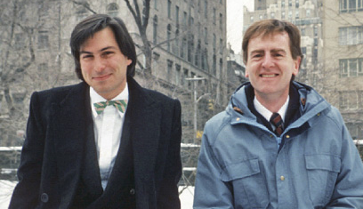

Walter Isaacson, in his biography of Steve Jobs, quotes one of Sculley's reminiscences: 'I was taken by this young, impetuous genius and thought it would be fun to get to know him a little better.'

That's exactly what he did, and during the honeymoon period everything seemed to be going swimmingly. As Michael Moritz writes in Return to the Little Kingdom, 'At Apple, Sculley was greeted like an archangel and, for a time, could do no wrong. He and Jobs were quoted as saying that they could finish each other’s sentences.'

Their management styles were wildly different, though, and it's perhaps inevitable that this led to some conflicts between the two men. Sculley didn't like the way that Jobs treated other staff members, and the two came to blows over more practical matters, including the pricing of the Macintosh.

From the moment of its inception, the Macintosh was always supposed to be a computer for the rest of us, keenly priced so that it would sell in large numbers. The aim was to put out a $1000 machine, but over the years of gestation – as the project became more ambitious – this almost doubled.

Shortly before its launch it was slated to go on sale at $1,995, but Sculley could see that even this wasn't enough and he decreed that it would have to be hiked by another $500. Jobs disagreed, but Sculley prevailed and the Macintosh 128K hit the shelves at $2,495.

That was just the start of the friction between the two men, which wasn't helped by a downturn in the company's fortunes. Sales of the Macintosh started to tail off, the Lisa was discontinued and Jobs didn't hide the fact that his initial respect for Sculley had cooled. The board urged Sculley to reign him in.

That's exactly what he did, but not until March 1985 - just shy of two years after arriving at the company. Sculley visited Jobs in his office and told him that he was taking away his responsibility for running the Macintosh team.

[Talking to the BBC in 2012](https://go.redirectingat.com/?id=803X112722&xcust=41-3606104-11-0000000&sref=https%3A%2F%2Fwww.macworld.co.uk%2Ffeature%2Fapple%2Fhistory-of-apple-steve-jobs-mac-3606104%2F&xs=1&url=http%3A%2F%2Fwww.bbc.co.uk%2Fnews%2Ftechnology-16538745), Sculley explained what went on inside the company at the time: "When the Macintosh Office [Apple's office-wide computing environment including networked Macintosh computers, file server, and a laser printer] was introduced in 1985 and failed Steve went into a very deep funk. He was depressed, and he and I had a major disagreement where he wanted to cut the price of the Macintosh and I wanted to focus on the Apple II because we were a public company. We had to have the profits of the Apple II and we couldn't afford to cut the price of the Macintosh because we needed the profits from the Apple II to show our earnings - not just to cover the Mac's problems. That's what led to the disagreement and the showdown between me and Steve and eventually the board investigated it and agreed that my position was the one they wanted to support."

But Jobs wasn't ready to go without a fight.

Sculley had to leave the country on business that May, and Jobs saw this as the perfect opportunity to wrest back control of the company. He confided in the senior members of his own team, which at the time included Jean-Louis Gassée, who was being lined up to take over from Jobs on the Macintosh team. Gassée told Sculley what was happening, and Sculley cancelled his trip.

The following morning, Sculley confronted Jobs in front of the whole board, asking if the rumors were true. Jobs said they were, and Sculley once again asked the board to choose between the two of them – him or Jobs. Again, they sided with Sculley, and Jobs' fate was sealed.

**Jobs leaves Apple**

Scully reorganized the company, installed Gassée at the head of the computer division and made Jobs Apple's chairman. That might sound like a plum job – indeed, a promotion – but in reality it was a largely ceremonial role that took the co-founder away from the day-to-day running of the company.

This wasn't Jobs' style. He felt the need to move on and do something else and, a few months later, that's what he did. He resigned from Apple and founded NeXT, a company that would design and build high end workstations for use in academia, taking several key Apple staff with him.

If this had happened in the 2000s, when Apple was riding high on the back of the iPod and iPhone and was prepping the world for the launch of the iPad, it could have had catastrophic consequences. In the 1980s, though, the outcome was somewhat different.

DeWitt Robbeloth, editor of *II Computing* magazine, wrote in the [October 1985 issue](https://go.redirectingat.com/?id=803X112722&xcust=41-3606104-11-0000000&sref=https%3A%2F%2Fwww.macworld.co.uk%2Ffeature%2Fapple%2Fhistory-of-apple-steve-jobs-mac-3606104%2F&xs=1&url=https%3A%2F%2Farchive.org%2Fstream%2FII_Computing_Vol_1_No_1_Oct_Nov_85_Premiere%23page%2Fn7%2Fmode%2F2up), "Most industry savants agree the move was good for Apple, or even crucial. Why? There were serious differences between the two about what Apple products should be like, how they should be marketed, and how the company should be run."

So, Sculley was in control and could run Apple as he saw fit. Now we'll see exactly where that takes the company over the following months. Read next: [12 Apple execs you need to know](https://www.macworld.co.uk/feature/apple/12-apple-execs-you-need-know-3525573/)

Jean-Louis Gassée takes over from Steve Jobs

The most recent stop of our tour through the history of Apple saw Jobs leave the company after falling out with the board. It wasn't entirely unexpected - and the news wasn't greeted with the same kind of dread as the announcement of his cancer many years later. Indeed, Wall Street responded positively to Jobs' departure, and the price of Apple stock went up.



Jean-Louis Gassée, who had been Apple's Director of European Operations since 1981, was appointed by CEO John Sculley to take over from Jobs and head up Macintosh development. Fewer positions could have been more prestigious in a company that owed its very existence to that single iconic product line - particularly at a time when the company's focus and ethos was about to undergo a significant change.

**Apple post-Jobs (the first time)**

In the months leading up to his departure, Jobs had been focused on consumer-friendly price points, initially wanting to sell the Macintosh for $1,000 or less into as many homes and businesses as possible. In the event, that never came to fruition, as the final spec simply couldn't be built, marketed and shipped at that price while still turning a profit.

However, with Jobs now busy elsewhere, the board was free to re-think what Apple was about and the kind of machines it would produce. It was already appealing to creative business users thanks to the prevalence of Macs in design and layout offices so, logically enough, it made the decision to target the high-end market with more powerful, and thus more expensive Macs. Although the company would sell fewer units, each one should - in theory - deliver similar or higher profits.

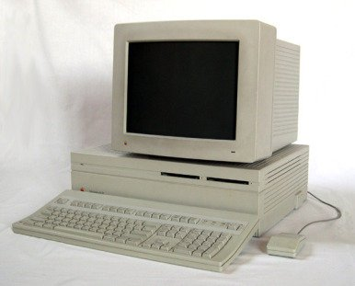

The policy had its own nickname, '55 or die', which was a nod to Gassée's dictate that the Macintosh II should deliver at least 55% profit per machine, perhaps explains why it was so expensive. A basic system with a 20MB hard drive (insufficient to hold an average Photoshop file today) started at $5500, but bumping up the spec, with a color display, more memory and larger hard drive, could easily see the price double.

When stood against their PC counterparts, then, Apple's new computers looked pretty expensive, but they had several benefits that kept their users loyal – in particular, the user interface. It's important to remember that although Windows may be ubiquitous today, that wasn't always the case.

When the Macintosh II first appeared in 1987, Windows was less than two years old, still at version 1.04, and still an add-on to DOS rather than a full-blown, stand-alone operating system.

Once the designers of the mid-1980s had got used to working visually, they didn't want to go back to using a text-based computer, so until Windows hit the big time, which happened with Windows 3 at the end of the 1980s, Apple had the graphical market pretty much to itself.

Apple gets colorful: the Machintosh II ships with a color display

This would be enough to encourage complacency in some companies, but not Apple, which continued to innovate in a way that would at least partially justify the high prices. The Machintosh II, for instance, wasn't simply a spec-boost of the original Macintosh. It looked completely different, being housed in a horizontal case that the end user (or an engineer) could open themselves to upgrade the memory, drives and so on. This was a major break from Apple's established way of doing things, where all previous computers, with the exception of the build-it-yourself Apple I, had been shipped in closed boxes, largely because Jobs saw this as a way of making them more friendly and less threatening.

It was also the first Macintosh to ship with a color display, and although it's difficult to imagine what a difference that would make today, we only need to think back to early, mono iPods and compare them to the iPod touch to understand the impact it must have had.

Aside from heading up the development of conventional computers, Gassée also oversaw a lot of Apple's behind-the-scenes development, where designers were dreaming up new products that would one day drive the company to new heights. Two of the fruits of those labors, the Newton Message Pad and the eMate, were particularly prescient, as they pointed towards Apple's later dominance of lightweight computing through the iPad and iPhone, but they didn't see the light of day before Gassée's own departure from Apple.

His tenure ran from 1981 until the end of the decade, which was the point the focus on highly-priced premium products started to falter. IBM clones were getting cheaper, and with the uptake of Windows and inexpensive desktop publishing applications, even some of Apple's most loyal customers were tempted to jump ship.

What Gassée did after Apple

The fourth quarter of 1989 marked the first time Apple had seen a drop in sales. The stock market got edgy, Apple's shares lost a fifth of its value, and despite having once been tipped to one day head up the company, Gassée left the following year. Like Jobs, he went on to found another radical computer company – in this case, Be Incorporated, which developed the BeOS operating system.

As we'll see in a later episode, his work with BeOS would come close to bringing Gassée back to the company. For now, though, Apple was focused on trying to win back some of the less wealthy customers by introducing a range of lower-priced computers, including the Macintosh Classic (8MHz processor, integrated mono display, $999), Macintosh LC (16MHz processor, pizza box case, color capable; the initials stood for LC, but it cost $999 without a display), and Macintosh IIsi (20MHz processor, large desktop case, $2999 without a display).

Today, amongst other things, Gassée writes a blog, [here](https://go.redirectingat.com/?id=803X112722&xcust=41-3606104-11-0000000&sref=https%3A%2F%2Fwww.macworld.co.uk%2Ffeature%2Fapple%2Fhistory-of-apple-steve-jobs-mac-3606104%2F&xs=1&url=https%3A%2F%2Fmondaynote.com%2F%40gassee%3Fgi%3Dfe28391d0749).

Unsurprisingly, after so many years of waiting, Apple customers lapped up these new, affordable machines, and the company enjoyed a revival. Indeed, by returning to basics, almost literally, Apple was back on the up, and about to wow the world with two of its most radical products ever, as we'll discover below.

[Jump to top of article](https://www.macworld.co.uk/feature/apple/history-of-apple-steve-jobs-mac-3606104/#history)

**Apple's decline and IBM and Microsoft's rise**

So Steve Jobs has gone, and so has Jean-Louis Gassée, his successor as head of product development. All in all, the future isn’t looking so bright for Apple at this point in its story. Despite initially being quite successful in chasing high profits with wide margins, its market is starting to shrink and, with it, so did its retained income. For the first time in the company’s history, its year-end results showed its cash balances to be rising more slowly than they had the year before.

That wasn't its only problem, though. IBM had been out-earning Apple since the mid-1980s, when it established itself as the dominant force in office computing. There was little indicating that this would change any time soon and, to make matters worse, Apple’s key differentiator was about to be dealt a close-to-lethal blow: Microsoft was gearing up for Windows 3 - a direct competitor to the all-graphical OS, System.

Windows had been a slow burner until this point. Versions 1 and 2 came and went without bothering Apple to much, but Windows 3 was a different story entirely. The interface was more accomplished, which for the first time supported 256 colors, and it was more stable thanks to a new protected mode. The graphical design language had been implemented from end to end, with icons in place of program names in Windows Explorer, its equivalent of the Mac’s Finder.

It could also run MS DOS applications in a Windows window, so it felt more like the unified graphical OS experience we know today - and which was already a hallmark of Apple’s GUI underpinnings. In short, more people than ever before could happily spend their whole day in a Windows environment, which would have left them asking why they would buy a Mac when there were so many PCs to choose from.

Apple's Quadra and Performa

Apple needed to up its game, which it did by developing a whole new line of computers that we now might think of as classics of their time: chiefly the Quadra and Performa, but also the less well-known Centris (which, as its name suggested, sat at the ‘Centre’ of the line-up).

The Performa line was, in effect, a case of Apple rebranding its existing stock, but bundling them with consumer-friendly software like ClarisWorks and Grolier Encyclopedia so they would appeal to the home user. The idea was to make them a viable stock item for department stores and other lifestyle outlets, as to date Apple's computers had only been available through authorized dealers and mail order (there was no such thing as the Apple Store back then).

It was a sound theory, and one that would have exposed the Apple brand to a whole new audience, but it didn't quite work as might have been expected. In part that was because the enormous range of slightly different models was confusing - so confusing that Apple went to the expense of producing a 30-minute infomercial showing a regular family choosing and buying a Performa. You can still find it online, [in six linked parts](http://bit.ly/1MWm75F).

It's unlike the kind of short and snappy advertising we're used to these days, devoid of catchphrases, and it spends a lot of time explaining not only why a Performa is the right choice, but also why Windows is difficult to use. It's hypnotic - and it's hard to argue with its message, too, if you can devote enough time to it.

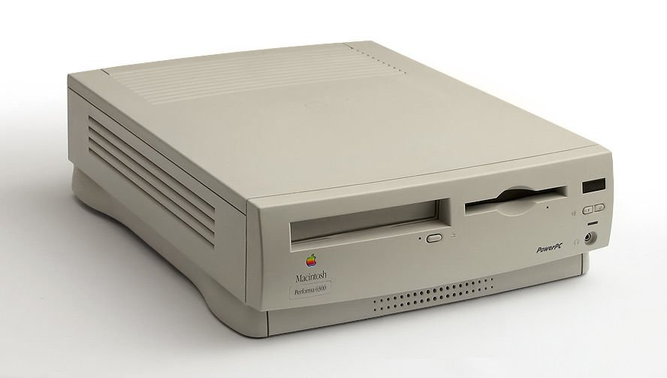

*Macintosh Performa 6300*

You can see a full list of the various Performa machines, and the original Macintosh models from which each one was derived on [Wikipedia](http://bit.ly/1Y4xPgk), and its clear from the minor differentiations between them that some of the simplicity on which Apple was founded - and to which it has since returned - had by now been lost.

Having so many computers to market and ship also meant the company had to try and predict which machines would sell best and build enough of each one to satisfy demand. That didn't always happen, and with Windows-based computers approaching ubiquity, Apple realized it was going to have to team up with one of its longtime rivals, IBM, if it was going to take a lead.

[Jump to top of article](https://www.macworld.co.uk/feature/apple/history-of-apple-steve-jobs-mac-3606104/#history)

The AIM Alliance: Apple teams up with IBM and Motorola

Together, Apple, IBM and Motorola founded the AIM Alliance in October 1991 (the name is their initials), to build a brand new hardware and software combo called PReP - the PowerPC Reference Platform. This ambitious project would go head to head against the existing Windows / Intel hegemony by running a next-generation operating system (from Apple) on top of brand new RISC-based processors (from IBM and Motorola).

Apple’s nascent operating system was codenamed Pink, and not without good reason. Much of the code was rolled into Copland, the aborted OS that we’ve encountered once before in our tour of the archives, and it came about following an extraordinary meeting in which all of the company’s future projects were written down on blue and pink card. Those that made it onto blue paper were comparatively easy and could be implemented in the short term.

Those written on pink would require more effort, and a longer timeframe. The next generation OS, was naturally noted on one of the latter.

AIM Alliance’s plans never came to fruition on the software side, and there were problems on the hardware front, too. When you bring together three notable players like Apple, IBM and Motorola, it’s to be expected that they’d each have their own ideas about the best way to do things so, perhaps it was inevitable that their differing views on the reference platform’s make-up didn’t always align.

If it had worked out, PReP might indeed have changed the face of computing. It didn’t, of course, but it did result in a change of direction for Apple. PReP's legacy was the PowerPC processor, which went on to form the bedrock of its computer line-up for years to come.

**The PowerPC years**

If you bought a new Apple computer any time between 1994 and 2006, you'll have taken home a PowerPC-based device, the genesis of which we explored above. The fruit of a productive collaboration between Apple, IBM (yes IBM) and Motorola - the AIM Alliance - it was, for a while, one of the most advanced platforms on the planet. Indeed, it proved versatile enough to sit at the heart of everything from the lowly iBook, right up to the mightiest enterprise-focused Xserve.

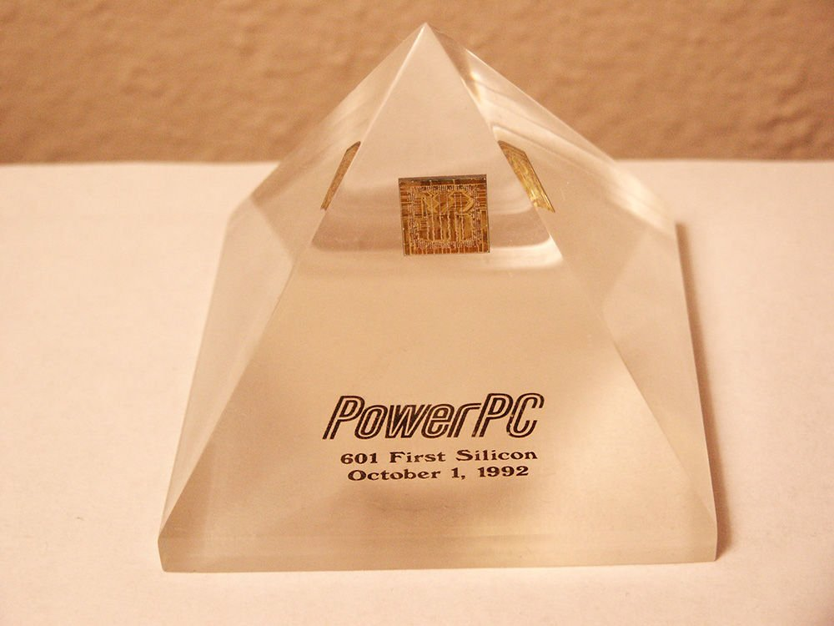

*PowerPC 601 Processor Prototype*

The name is an acronym for Performance Optimization With Enhanced RISC-Performance Computing, and its core technology was based on IBM's POWER instruction set, so even though it was an innovation of the early-1990s it wasn't an entirely alien platform for developers coding for the Mac.

This helped make PowerPC a viable alternative to the x86-based processors being shipped by Intel and AMD, which were then dominating the computing market. Even Microsoft shipped a version of Windows NT for PowerPC before scaling back to focus solely on x86 and, later, Freescale.

The first PowerPC-based Macintosh (pre-Mac) was 1994's Power Macintosh 6100 which, as its name suggests, was based on the 601 processor, running at 60MHz and developed using code that was already familiar to engineers from both Motorola and Apple. As the Quadra's successor, it was the first machine able to run Mac OS 9, which would likely have been a big enough sales point on its own.

However, perhaps hedging its bets (platform transitions are nerve-wracking projects, after all) it also released a DOS-compatible version, which instead used an Intel 486 processor and allowed Windows and Mac OS to be run simultaneously, effectively doing what VMware Fusion and Parallels Desktop do today, and VirtualPC did in the PowerPC line's latter years.

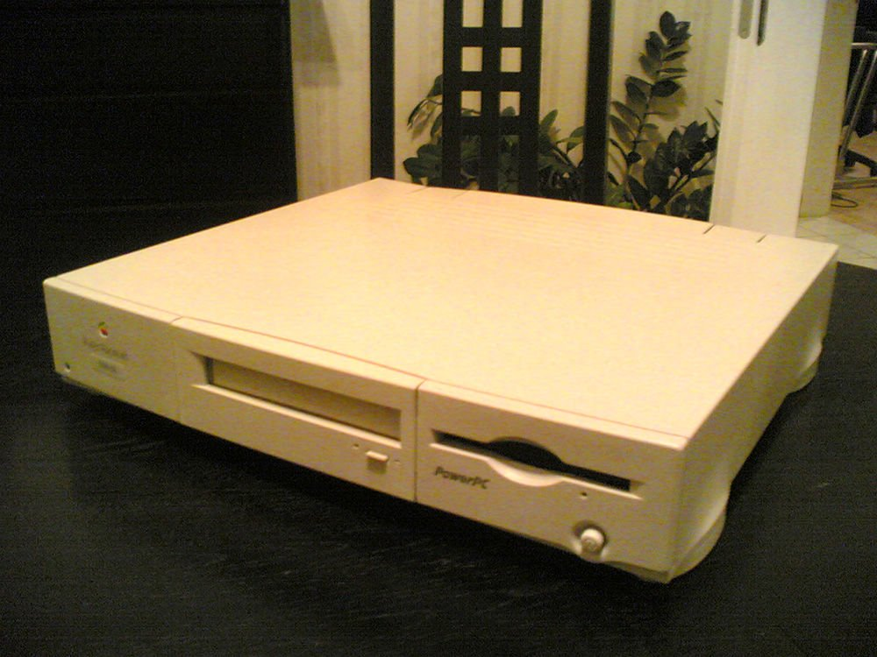

*Power Macintosh 6100*

The 6100 was released in concert with the beefier Power Macintosh 7100, which had been developed under the internal codename 'Carl Sagan'. It was a convoluted choice, based on the belief that the computer was so brilliant it would make the company 'Billions and Billions', which just happened to be the name of a book written by astronomer Carl Sagan, who used to stress the letter 'B' when saying the word 'billions' so people wouldn't confuse it with millions.

Although it was never used to market the 7100, Sagan claimed that customers might have considered the codename, which was revealed in a magazine, to imply that he endorsed the product. He wrote to the magazine, asking them to make it clear that he did not, at which point Apple's development team re-named the computer BHA, for Butt-Head Astronomer. Sagan sued for libel and lost, with the court ruling that ["one does not seriously attack the expertise of a scientist using the undefined phrase 'butt-head'"](https://go.redirectingat.com/?id=803X112722&xcust=41-3606104-11-0000000&sref=https%3A%2F%2Fwww.macworld.co.uk%2Ffeature%2Fapple%2Fhistory-of-apple-steve-jobs-mac-3606104%2F&xs=1&url=http%3A%2F%2Fwww.leagle.com%2Fdecision%2F19941946874FSupp1072_11772%2FSAGAN%2520v.%2520APPLE%2520COMPUTER%2C%2520INC.).

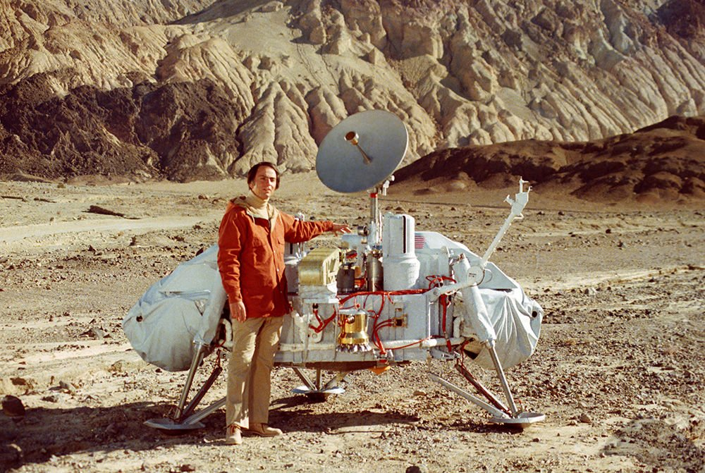

*Carl Sagan*

Eventually the two parties settled out of court, at which point the 7100 was again renamed, this time to LAW, or Lawyers Are Wimps.

The PowerPC line enjoyed a good innings, but by the middle of this century's first decade (we're jumping ahead a bit here to tie-up the PowerPC story), fractures were starting to appear in the alliance and the platform wasn't evolving quickly enough to keep consumers happy. Apple's high-end notebook, the PowerBook, was starting to look a little underpowered, and in an effort to push the processor in the Power Mac G5 beyond its native rating, it produced three special editions that employed a sophisticated water cooling system that allowed it to overclock the processor without it overheating.

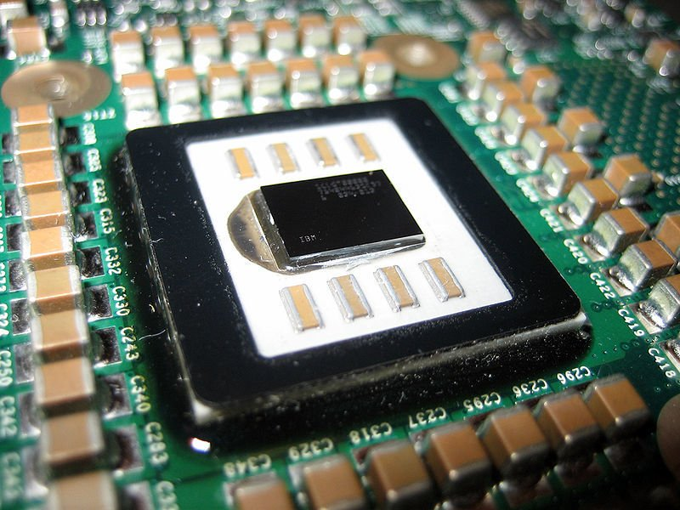

*PowerPC 970FX processor, as used in one of the last Power Mac G5s*

Those in the know began talking about parallel teams working inside Apple HQ on a version of OS X that would run on Intel processors. The gossip was never confirmed, but the fact it had even been mooted meant [Jobs' 2005 announcement that the company would shift its entire line-up to Intel hardware](https://www.macworld.co.uk/feature/mac-software/macworld-feature-ten-years-mac-os-x-3483890/?p=3) was less of a shock than it might have been.

Jumping ship just four years after the introduction of OS X would have been too big a move for many CEOs, who might have been afraid that they'd frighten away their customers. As Macworld wrote, 'It was a big gamble for a company that had relied on PowerPC processors since 1994, but Jobs argued that it was a move Apple had to make to keep its computers ahead of the competition. "As we look ahead... we may have great products right now, and we've got some great PowerPC product[s] still yet to come," Jobs told the audience at the 2005 Worldwide Developers Conference. "[But] we can envision some amazing products we want to build for you and we don't know how to build them with the future PowerPC road map."'

You might have expected developers to be up in arms: after decades of honing their code to run smoothly on PowerPC architecture, they'd have to throw it away and start from scratch, but Apple gave them a crutch, at least in the interim. Rather than cut off support for legacy code from day one, it built a runtime layer into OS X Tiger (10.4), called Rosetta, a name inspired by the Rosetta Stone, the multi-lingual engravings on which were the key to understanding hieroglyphics.

This interim layer intercepted Power G3, G4 and AltiVec instructions and converted them, on the fly, to Intel-compatible code. There would have been a slight performance hit, naturally, but it was an impressive stopgap, and one that Apple maintained until it shipped Lion. (Although [Snow Leopard](https://www.macworld.co.uk/news/mac-software/how-do-i-get-snow-leopard-how-get-snow-leopard-so-you-can-update-os-x-mavericks-updated-3400115/), the last iteration to support it and the first for which there was no PowerPC release, didn't install it by default - you had to add it manually.)

PowerPC lives on, not only in the countless legacy Macs that are still putting in good service, but in consumer devices like the Wii U, PlayStation 3 and Xbox 360, as well as in faceless computing applications where it's a popular choice for embedded processing.

Of course, during the 12 years of PowerPC's dominance, many other things were going on behind the scenes. Apple was working on the Newton Message Pad, chipping away at a revolutionary operating system that never shipped and, as a result, bought Steve Jobs' company NeXT and, with it, Jobs himself, ensuring Apple's survival.

[Jump to top of article](https://www.macworld.co.uk/feature/apple/history-of-apple-steve-jobs-mac-3606104/#history)

**Apple and Microsoft**

If IT was a soap opera, Apple and Microsoft's on-off relationship would put EastEnders to shame. Today, you'd never guess there had ever been anything wrong, and that's probably down to the fact that their relationship has never been more symbiotic.

IDC figures released in summer 2015 showed [Mac sales to have climbed by 16%](https://go.redirectingat.com/?id=803X112722&xcust=41-3606104-11-0000000&sref=https%3A%2F%2Fwww.macworld.co.uk%2Ffeature%2Fapple%2Fhistory-of-apple-steve-jobs-mac-3606104%2F&xs=1&url=http%3A%2F%2Fappleinsider.com%2Farticles%2F15%2F07%2F09%2Fnew-idc-numbers-show-mac-sales-up-161-percent-in-june-quarter) over the previous quarter. At the same time, though, the overall PC market for machines running Windows had dipped by 11.8%. So, with ever more of Microsoft's revenue coming from Office 365, it needs to push its subscription-based productivity service onto as many platforms as it can - including Android, iOS and, of course, the Mac.

Apple, on the other hand, *needs* Office. It has its own productivity apps in the shape of Pages, Numbers and Keynote, but Word, Excel and PowerPoint remain more or less industry standards, so if it’s going to be taken seriously in the business world, Apple needs Microsoft Office onboard.

So, a peace has broken out - and a long-lasting one at that, which despite some sniping from either side, stretches right back to Jobs' return to Apple after his time at NeXT. We’ll come to that later, but suffice it to say at this point that it shouldn't really surprise us: the rivalry between the two camps often seems overblown.

Microsoft developed many of the Office apps for the Mac before porting them to the PC and, in the early days at least, Bill Gates had good things to say about the company. "To create a new standard, it takes something that's not just a little bit different," he said in 1984, "it takes something that's really new, and really captures people's imagination. And the Macintosh - of all the machines I've seen - is the only one that meets that standard."

That's pretty flattering, but there's a saying about flattery: imitation is its sincerest form. Apple apparently didn't see it that way when Microsoft, in Apple's eyes, went on to imitate its products a little *too* faithfully.

As we already know, Apple had been inspired by certain elements of an operating system it saw at Xerox PARC when it was developing the Macintosh and Lisa. Xerox's implementation used the desktop metaphor now familiar to OS X, Windows and many Linux users, and when Microsoft was developing Windows 1.0, Apple licensed some of its fundamentals to the company that Jobs latterly took to calling "our friends up north".

That was fine when Windows was just starting out, but when version 2 hit the shelves, with significant amendments, Apple was no longer so happy to share and share alike.

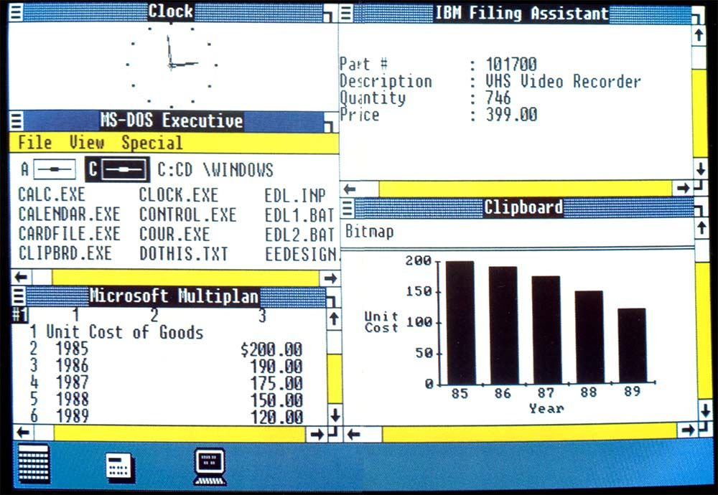

*Microsoft Windows 1.0*

Most significantly, Microsoft had implemented one of the features of which Apple was proudest: the ability to overlap live application windows. This is more complex as it sounds, as it requires some advanced calculations to determine which parts sit beneath others, not to mention how they should behave when repositioned.

However, Apple’s primary argument was that, taken as a whole, the generic look and feel of a graphical operating system - such as its resizable, movable windows, title bars and so on - should be subject to copyright protection, rather than each of the specific parts. Looking back on it now, it’s easy to see that this would be akin to Ford copyrighting the idea of a car, rather than a specific engine implementation or means of heating the windscreen, but back then, the GUI was such an innovation that you can understand why Apple would have wanted to protect it.

The court didn't buy into the idea of look and feel, and asked Apple to come back with a more specific complaint, highlighting the parts of its own operating system that it believed Microsoft had stolen. So, Apple made a list of 189 points, of which all but 10 were thrown out by the court as having been covered by the licensing agreement drawn up between the two parties with respect to Windows 1.0. That left Apple with just 10 points on which to build its case.

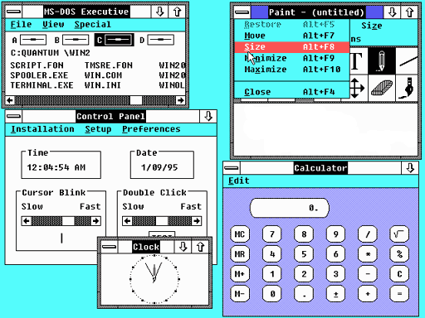

*Microsoft Windows 2.0*

However, over at PARC, Xerox could see that if Apple won it might be able to claim the rights to those elements itself, even though they'd been dreamed up following on from Jobs et al's tour of its labs. Xerox had no choice but to mount a claim itself, against Apple, stating that the operating environments on the Macintosh and Lisa infringed its own copyrights.

Ultimately, Xerox's act of self-defense was unnecessary as the court ruled against Apple, deciding that while their specific implementation was important, the general idea of using office-like elements, such as folders and a desktop, was too generic to protect.

Apple appealed, but to no avail. However, it did at least avoid losing to Xerox, as the Palo Alto company’s claim was thrown out.

Of course, Apple and Microsoft patched things up eventually, and for that we should all be grateful. If they hadn't, it's possible there might be no Mac today. Why? Because when he came back to Apple and set about returning it to greatness, Jobs realized that he couldn't do it alone. He might have a streamlined hardware line-up waiting in the wings, headlined by the groundbreaking iMac, but he knew that without the software to back them up they’d never attain their full potential.

Business users wouldn't switch to a platform that didn't support industry standard document formats, like those produced by Word, Excel and PowerPoint, and that remains true today. While home users and small teams will be happy to use Pages, Numbers and Keynote, IT departments - particularly those in mixed-platform offices - often still rely on Microsoft Office formats.

So, [Steve Jobs put in a personal call to Bill Gates](https://go.redirectingat.com/?id=803X112722&xcust=41-3606104-11-0000000&sref=https%3A%2F%2Fwww.macworld.co.uk%2Ffeature%2Fapple%2Fhistory-of-apple-steve-jobs-mac-3606104%2F&xs=1&url=http%3A%2F%2Fwww.telegraph.co.uk%2Ftechnology%2F7213848%2FApple-v-Microsoft-What-Steve-Jobs-and-Bill-Gates-really-think-of-each-other.html), who was then Microsoft's CEO, and convinced him to keep developing Office for Mac for at least the next five years. Gates did just that, and at the same time Microsoft bought $150m worth of non-voting Apple stock, thereby securing its future.

In return, Apple unseated Netscape as the Mac's default browser and installed Internet Explorer in its place, which was actively developed right up until 2003, when in the face rumors that Apple was working on its own browser in house - Safari - Microsoft scaled back its work on IE for Mac to the point where, today, it no longer runs on OS X.

**Apple in the 1990s**

Apple was a very different company in the 1990s to the one we know today. It had a lot of products and a lot of stock, but not enough customers. There's only so long a company can survive like that.

Looking back on it now, you'd be forgiven for thinking it was losing its way. Alongside its computer range, it was producing digital cameras (where it was ahead of most of the big-name players that now dominate photography), video consoles, TV appliances and CD players. It had also invested heavily in the Newton platform to produce the Message Pad and eMate lines.

In many respects, to use a well-worn cliche, it was running before it could walk. Almost all of these products have equivalents in Apple's current line-up where they form the basis of the iPhone camera, Apple TV, iPad and so on, but in the 1990s there was no way to link them all together. They were, to all intents and purposes, disparate and largely disconnected products; there was no overarching storyline to what Apple was producing the way there is now, where the Mac, Apple Watch, Apple TV and iOS devices can all share data courtesy of iCloud.

To make matters worse, the decision to license a lot of its technologies was only making it harder for Apple to succeed in each marketplace, as it was enabling its rivals to produce cheaper cloned versions of its top-line products. Even the Newton platform wasn't immune, with Motorola, Siemens and Sharp, among others, using the operating system and hardware spec to build their own products.

Cloning remains a contentious issue in Apple history. Aside from being bad news from Apple's in-house hardware development, many consumers would say it was actually good for the end user, as it encouraged competition and, as a result, lowered prices. That brought more people to the platform than Apple would have managed to attract on its own, which in turn ensured continued support from application developers, including key names like Adobe and Microsoft, without whom the computer line-up may well have collapsed.

But something had to give - and a decision had to be made, which turned out to be one of the most momentous decisions in the company's history.

**Jobs returns to Apple**

Apple was still on the lookout for a new operating system, as its in-house efforts weren't going as well as it had hoped. By 1996 it had shortlisted two possible suppliers: BeOS and NeXTSTEP, each of which had a historical connection to Apple itself.

BeOS was developed by Be Inc, a company founded by former Apple executive, Jean-Louis Gassée. He had been appointed as Apple's director of European operations in 1981 and, four years later, was responsible for informing Apple's board of Jobs' intention to oust CEO John Sculley - the act that led to Jobs' departure from the company.

NeXTSTEP, on the other hand, came from NeXT - the company that Jobs founded upon leaving Apple. Although NeXT's hardware didn't go on to sell in the quantities that Apple was shipping, it was highly thought of and is perhaps best known as the platform on which Tim Berners Lee developed the World Wide Web while working at Cern.

The stakes couldn't have been higher for either man - or either company - but in the end Apple chose NeXTSTEP.

If it had been a simple licensing deal that wouldn't have been so remarkable, but in truth it was far more than that. Apple purchased NeXT itself - not just its operating system - for $429m in cash, plus 1.5 million shares of Apple stock, effectively buying back Steve Jobs in the process.

The man who had co-founded the company was returning to it after 12 years away.

Making changes

Buying NeXT wasn't enough to fix Apple's ongoing woes on its own. Its share price was declining, and over the next six months it fell still further, to a 12-year low.

Jobs convinced the board of directors that the company's CEO, Gil Amelio, had to go and, when it agreed, it installed Jobs in his place as interim CEO. At that point, Apple began a remarkable period of restructuring that leads directly to the successful organization it is today.

Jobs recognized that if Apple was going to survive it needed to concentrate on a narrower selection of products. He slimmed down the range of computers to just four - two for consumers and two for businesses - and closed down a lot of supplementary divisions, including the one working on the Newton.

At the same time, he saw that the licensing deals it had signed weren't doing it any favors, and he brought them to an end. The immediate effect wasn't good, as it saw the market share of new computers running Apple's operating system dropping from 10% to just 3% - but at least 100% of them were being built by Apple itself.

The strategy paid off in the long run, though, and Apple's computers and operating system are holding their own in a world where rivals are seeing year on year stagnation or - worse - decline.

Not everyone was convinced, though. When asked what he would do to fix the broken Apple Computer Inc, Michael Dell, who founded the Windows-based rival that carries his name, told a Gartner Symposium, 'What would I do? I'd shut it down and give the money back to the shareholders.'

Dell was riding high at the time, but over the years the two companies' relative positions have changed, and in 2006 Jobs mocked his rival in an email he sent to Apple staff.

"Team," the email read. "It turned out that Michael Dell wasn't perfect at predicting the future. Based on today's stock market close, Apple is worth more than Dell. Stocks go up and down, and things may be different tomorrow, but I thought it was worth a moment of reflection today."

And were things "different tomorrow"?

Maybe not tomorrow, but certainly in the long run they were very different indeed. Apple grew to become the most valuable company in the world when measured by market capitalization, while Dell went back to private ownership, as Michael Dell and Silver Lake Partners bought out the existing shareholders.

If you'd like to reminisce more, visit our [Apple History Zone](https://www.macworld.co.uk/mac-at-30/), where you can find:

[How the Mac changed, and continues to change, the world](https://www.macworld.co.uk/feature/mac/how-mac-changed-continues-change-world-3498814/)[30 Apple people from the history of the Mac](https://www.macworld.co.uk/feature/mac/apple-30-important-people-history-mac-24582/)[5 Macs that changed everything](https://www.macworld.co.uk/feature/mac/5-macs-that-changed-everything-3497789/)video The history Apple

Tags:

* [Apple](https://www.macworld.co.uk/apple/),
* [The Mac at 30](https://www.macworld.co.uk/mac-at-30/),
* [Steve Jobs](https://www.macworld.co.uk/steve-jobs/),